PANKAJ ( SAP PP/QM/PM/PS) Consultant)


To become a contributing sap functional consultant in an organization for its success, by applying the best business practices through innovative solutions and constantly updating my skills

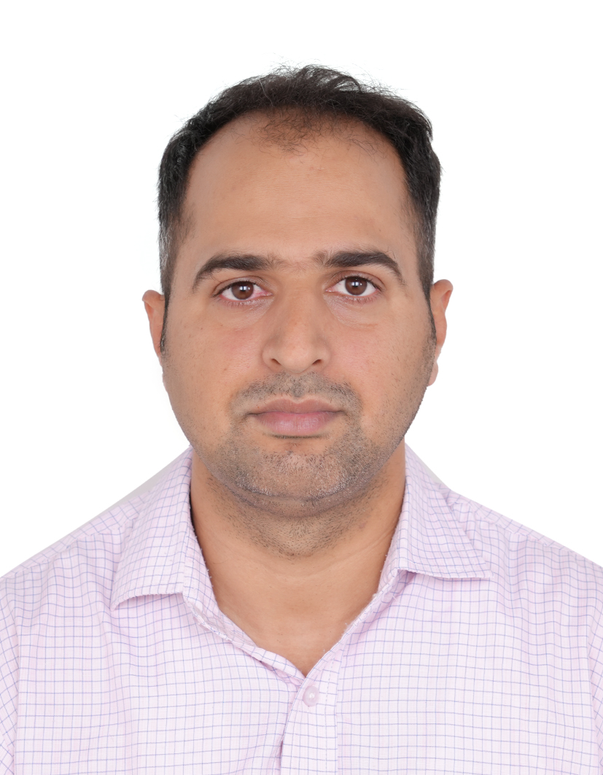
SAP PP-QM Consultant  Academic Details  - B.Tech(Chemical Engg.) KUK University , Haryana with 73.1% in 2012  - 12th(Non medical) Govt.S.S.School,Kaithal  - HARYANA with 80 % in 2007-08  - 10thGovt.Sr.Sec.School, ,HARYANA with 84 % in 2005-06  Certification Course  - SAP global certified Production Planning & Manufacturing with SAP ERP 6.0-ID:0018275915  - SAP Certified Application Associate - SAP S/4HANA Cloud - Public Edition - Manufacturing 2023 | Profile Summary
- Excellent track record with rich experience with various project in SAP PP with domain expertise.
- Involved in 3 SAP-S4 HANA Greenfield Implementation(Global Client) ,1 ECC to S4 HANA Technical Migration , 2 ECC 6.0 implementation and Multiple role out & various support projects (Business requirement collection, Business process analysis, GAP analysis, Design, Configuration, Proof of concept, Unit testing, Data migration, Integration testing, Cut-off strategy, Go-live and Post-go-live support.
- Managing Master Data related to PP & QM and upload the data in Mass by LTMC , LSMW & IDOC.
- Knowledge of SAP PP, PP-PI & repetitive manufacturing with MTS, MTO strategies.
- Good configuration knowledge of PS structures: WBS, Network, Milestones, Cost Planning, Budgeting, Material Requirement planning, Project quotation, Goods issues, and other project management activities in SAP PS.
- Maintenance Breakdown, Preventive, General Maintenance, Maintenance Estimation, Calibration.
- Knowledge of configuration and customization of Production Planning functionality: Master Data Material Requirement Planning, Production Strategies, Capacity Planning, Demand Management, MRP.
- Experienced in gathering Business requirements from Clients and designing Functional specifications for Change requests/Enhancements.
- Integration knowledge of SAP PP with other modules like MES, EWM,MM, SD, CO etc. & Knowledge of basic debugging.
- Extensively contributed to end user training, production support and Change Management.
- Excellent relationship management and communication skills with the capability to network with consummate ease.

ORGANISATIONAL EXPERIENCE

YASH Technologies Middle East FZ LLC
(working as SAP-PP/QM/PM Consultant JAN 2025 to till date)

- Project : Qaiwan Group (Iraq ) (S4 HANA 2023)
• Conducting Workshop with Global Team to understand current business process & gaps within Global business.
• Consolidating TO-BE Processes into Global Business Blueprint Template.
• Identifying Gaps and how they could be mapped into SAP system.
• Preparing Functional Specification document for WRCIEF objects.
• Master Data–Material Master, MICs, Inspection Method, Catalogs, Sampling Procedure, Sampling Scheme, Inspection Plan, Routing, Quality Inspection, Quality Notification, Quality Certificate.
• General Maintenance Cycle, Preventive, Shut Down, Refurbishment, Breakdown, Recondition, Fabrication, Calibration Cycle,Capital Repair Maintenance

- Project : TAQA ;The Abu Dhabi National Energy Company, PJSC is a government controlled energy holding company of Abu Dhabi, United Arab Emirates.-S/4 HANA 2021 (SAP PP-QM Lead – Jan-25 to July 2025)

- Conducting Workshop with Global Team to understand current business process & gaps within Global business.
- Consolidating TO-BE Processes into Global Business Blueprint Template.
- Identifying Gaps and how they could be mapped into SAP system.
- Preparing Functional Specification document for WRCIEF objects.
- Master Data–Material Master, MICs, Inspection Method, Catalogs, Sampling Procedure, Sampling Scheme, Inspection Plan, Routing, Quality Inspection, Quality Notification, Quality Certificate.
- Coordinating with technical team for the development, enhancements, forms and reports.
- Integration with MM,QM, SD and FICO ; EWM.

Previous Organisations

- Yash Technology Ltd.; Gurgaon
(Working as SAP Manufacturing Consultant (PP/QM) Apr 2021 to 13 December 2024)

- Project: ECOBAT (USA): Battery Recycling Company - S/4 HANA 2020
- Conducting Workshop with Global Team to understand current business process & gaps within Global business.
- Process, Discreet & Repetitive Industry solution is utilized as per Business requirement.
- Consolidating TO-BE Processes into Global Business Blueprint Template.
- Identifying Gaps and how they could be mapped into SAP system.
- Preparing Functional Specification document for WRCIEF objects.
- Master Data–Material Master, MICs, Inspection Method, Catalogs, Sampling Procedure, Sampling Scheme, Inspection Plan, Routing, Quality Inspection, Quality Notification, Quality Certificate.
- Configured certificate profiles and implementation of certificates of analysis.
- Experience Covers QM blueprinting, realization, testing/validation, cutover and go-live activities.
- Coordinating with technical team for the development, enhancements, forms, and reports.
- Integration with MM, QM, SD, EWM and FICO.
- Creation of Batch Class, Characteristics, Batch Management Configuration and Batch Where-Used-List.

- Weir Minerals (Netherland) – Roll out – ECC 6.0
- Conducting Workshop with Global Team to understand current business process & gaps within Global business.
- Consolidating TO-BE Processes into Global Business Blueprint Template.
- Identifying Gaps and how they could be mapped into SAP system.
- Preparing Functional Specification document for WRCIEF objects.
- Testing, Legacy System Data Conversion, Integration Testing, UAT & GO-live & Hyper care support.
- Organized legacy data and used LSMW to successfully load all records.

- Tech Mahindra Ltd.
(SAP-PP Consultant Sep-2020 to Mar 2021)

Project: Customer: National Fertilizer Industry (SAP S/4 HANA 2020)

- Understanding client’s business processes, AS-IS Processes and mapping them in to TO-BE Processes into SAP.
- Successfully developed training material, training exercises and provided individual and group training sessions to the end users.
- Extensive work with SOP, demand management, production control and goods movement functionality within SAP.
- Performed Global support by resolving Tickets
- Strongly coordinated with ABAP and EWM Team to resolve various user related issues.
- SAP overview and OCM training for end users.

- Tata Consultancies Services

(working as SAP-PP Consultant Feb-2019 to Sep-2020)(ECC 6.0)

- Project : Customer :OWENS Corning (500 fortune company ) (USA Based)
- Requirements gathering, remote meeting with business stakeholders & on-site team.
- Roll out for Europe plants with highly integrated environment.
- PP-MES integration via PI interface.
- Highly integrated & complex system support for MFG modules (PP/QM/PM) to region North America & EU & optimization for the existing system.
- S/4 Hana POC to client for upgration from ECC 6.0 TO S/4 HANA.

- Project: Customer: JK TORNEL MEXICO ( SAP EHP-7.0)
- Requirements gathering, remote meeting with business stakeholders & making BBP document, Configuration Document & visit On-Site & deliver the project.
- Testing, Legacy System Conversion, Integration Testing, UAT & GO-live & Hyper care support.
- Involved in the preparation of functional and technical specifications, Change of Custom enhancements as per new business, preparing training material and documentation.

- Fiem Industries Ltd. (Leading manufacturers of Automotive Lighting, Signalling Equipment’s, Rear View Mirrors, Sheet Metal and Plastic Parts)
(working as SAP-PP Consultant Oct-2018 to Feb-2019) ( SAP-S4HANA-1709)
- Implementation includes Requirement gathering, Testing, Final Preparation, Go-Live, Training and Support.
- Configuration of Master Data, Material Requirement Planning, Capacity Planning, Demand Management, Batch Management.
- Involved in the preparation of functional and technical specifications, review of Custom enhancements & user exits, preparing training material and documentation.
- Configuration of rework order & dismantle process.
- Enhancement in production order confirmation.

- Tide Water Oil Co. (India) Ltd. (working as SAP-PP Consultant MAY-2015 TO SEP-2018) ( SAP ECC 6.0)
- Reviewed and analysed monthly and weekly production plan against target volume against capacity and resources
- Optimizing man & machine utilization to achieve preset production targets.
- Reviewed and analysed monthly and weekly production plan against target volume .
- Continually looks for opportunities to improve manufacturing time and cost and provides metrics to support the improvements.
- Co-ordinate with Sales Manager and Executives regarding quality and customer feedback & Provide technical support and assistance to them.
- ISO 9001 : 2015 Documents and maintain it

- Yushiro India Pvt. Ltd.; Japanese MNC (manufacturing of metal-working fluid) as a production engineer (SAP PP/QM Super User)
(from 16 Sep, 2013 to 23 May, 2015)
Role:
- Production Planning and blending operations of metal working fluid.
- Responsible for optimum utilization of resources like, man power, machinery and material
- Improvements and adopting cost reduction techniques and give costing for material manufactured.
- Making preventive maintenance schedule for various machines and maintain the machinery.
- Optimizing man & machine utilization to achieve preset production targets

- Worked in ASSA, Barhi, Sonipat(Haryana) (Manufacturing of coating, paint) as an production Engg. (1 sep 2012 to 13 sep 2013)

Role:
- Production and Quality control of coating, pigment, shoe polish.
- Achieve production target as per given planning.
- Small scale production in laboratory and rectify problems in product if any.

PERSONAL DETAILS

Father Name: MR. RAJENDER SHARMA
Mother Name: Mrs. Santosh Devi
Date of Birth: 25th Dec 1990
Languages Known: English & Hindi
Address Delhi (India)

